

C A R I B B E A N

M E T E O R O L O G I C A L

O R G A N I Z A T I O N

**CARIBBEAN METEOROLOGICAL COUNCIL** **Doc. 3(a)**

FIFTY-SIXTH SESSION

St. George's, GRENADA, 10-11 NOVEMBER 2016

**THE COORDINATING DIRECTOR’S REPORT - 2016**

**ON CMO HEADQUARTERS UNIT ACTIVITIES**

(Submitted by the Coordinating Director)

1. This document highlights activities of the CMO Headquarters since the 55th session of the Council, held in Belize City, Belize on 12-13 November 2015. Factors affecting operational aspects at the Headquarters and other matters of interest are also mentioned for information and guidance where appropriate. Details of some activities and developments, where necessary, will be dealt with under separate agenda items.

2. Since the last session of the Caribbean Meteorological Council in November 2015, the weather has been a feature in one form or another. 2016 was quite different to 2015. In 2015, the atmosphere was generally dry under the influence of a moderate to strong *El Niño* with cooler than normal sea surface temperatures in the North Atlantic Ocean, which were not conducive to the formation of a large number of tropical storms and hurricanes, although the region was hit by *Tropical Storm Erika* in August. The El Niño peaked late in the year 2015 and began gradual weakening. The general drought conditions continued into the first half of 2016 even as the El Niño weakened. Regular rainfall generally returned to the region towards the start of the normal wet season.

3. In the Caribbean/Atlantic basins, the seasonal average is 12 named storms, including six hurricanes, of which three would be major hurricanes. In 2016, tropical storms remained away from the region until August, when ***Hurricane Earl*** crossed Belize. On August 3rd and 4th, Hurricane Earl made landfall just southwest of Belize City with winds in the vicinity of 80 mph (130 km/h). The combination of 9–12 in (230–300 mm) in rainfall and a [*storm surge*](https://en.wikipedia.org/wiki/Storm_surge) flooded coastal areas across central and northern Belize. Reports indicate that Hurricane Earl damaged or destroyed approximately 2,000 homes in Belize, affecting 10,000 people. Agricultural damage was estimated at over US$100 million, with the overall damage estimated at US$110 million.

4. From September onwards, the hurricane season really became very active. Five named storms formed in the Atlantic basin in September alone. One of these, ***Matthew***, reached tropical storm strength as it reached the Eastern Caribbean island chain. Floods, landslides and other damage were experienced in Barbados, Saint Lucia and St. Vincent & the Grenadines, with the loss of one life reported in St. Vincent and the Grenadines. Matthew then developed to *major hurricane strength* (category 5) over the south-central Caribbean Sea, before turning north and impacting Haiti, the Dominican Republic, Jamaica, Cuba, the Bahamas and parts of the South-eastern USA. Unofficial figures indicate between 400 and 1,000 lives lost in Haiti alone, as well as at least 39 deaths across five South-eastern US States. ***Hurricane Matthew*** is now listed as the strongest hurricane in the Atlantic-Caribbean Basin since *Hurricane Felix* in 2007 and the deadliest since 2005.

5. The very active hurricane season is well depicted in the season summary map, prepared at the middle of October 2016, shown as **ANNEX I.** By the middle of October 2016, there were 14 named storms, including six hurricanes, two of which were classified as major hurricanes. Of these, *Earl* and *Matthew* were the only two in the Caribbean Sea, which underscores the general preparedness rule that it only takes one depression, storm or hurricane making landfall to make it an active or disastrous season for an affected place. Some images of *Hurricane Earl* and *Hurricane Matthew* are shown in **Figures 1** and **2** below. The one notable Atlantic cyclone in October was *Hurricane Nicole*, which made a direct hit on Bermuda on 13 October. It was the strongest hurricane to strike the island since Hurricane Fabien in 2003.

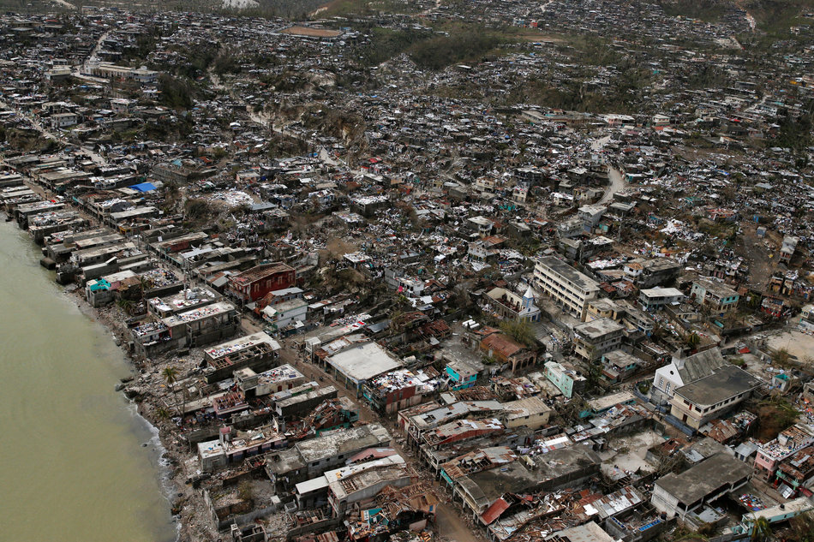

**Figure 2(b):** Hurricane Matthew’s destruction in Haiti. Courtesy: Reuters

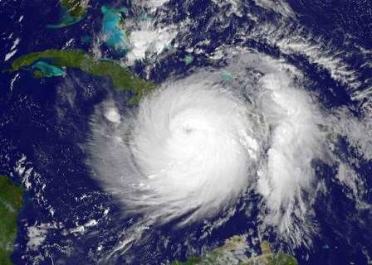

**Figure 2(a):** Satellite image of Major Hurricane Matthew affecting Haiti and Jamaica Aug 3, 2016. Courtesy: NOAA

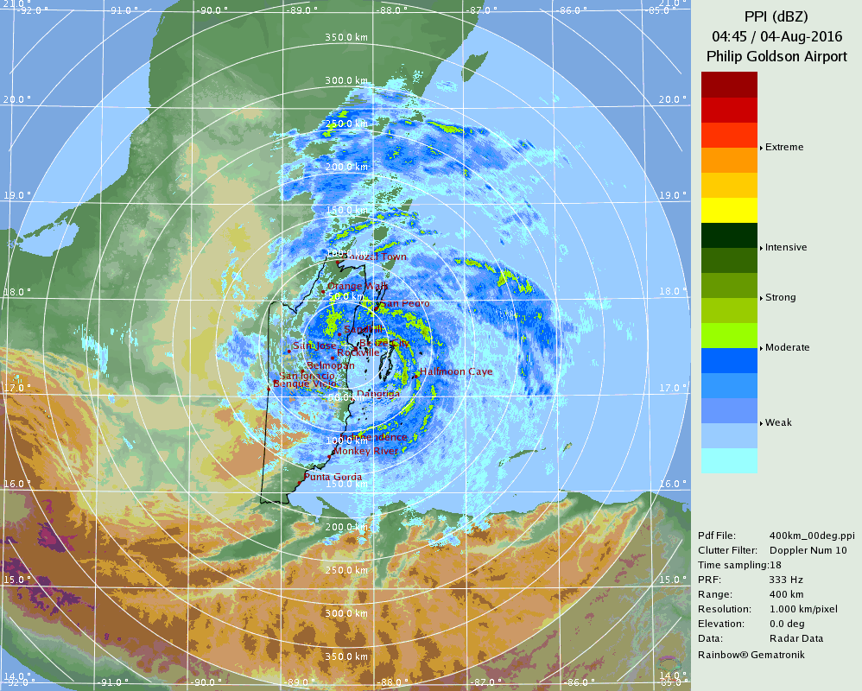

**Figure 1(b):** Belize Weather Radar – Hurricane Earl, 4:45AM Aug 4, 2016. Courtesy: Belize Meteorological Services

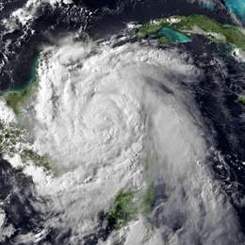

**Figure 1(a):** Satellite image of Hurricane Earl affecting Belize Aug 3, 2016. Courtesy: NOAA

6. Throughout the Hurricane season, the CMO Headquarters routinely monitors the effectiveness of the regional warning system, including the timeliness and content of the various warnings issued by the National Meteorological and Hydrometeorological Services (NMHS) in Member States, as well as the response by disaster management agencies. For Hurricane Earl and Tropical Storm/Hurricane Matthew, the warnings issued by the affected Meteorological Services in Member States were very timely and effective. Before the start of the 2016 hurricane season, as a contribution to regional hurricane preparedness, the CMO Headquarters organized a visit to Tortola in the British Virgin Islands by one of the hurricane reconnaissance aircraft, known as a “*Hurricane Hunter*”, operated by the United States Air Force Reserves. This was part of the annual **Caribbean Hurricane Awareness Tour** (CHAT), carried out by the USAF and the US *National Oceanic and Atmospheric Administration* (NOAA). CMO is already organizing with the US authorities for a similar tour to two Caribbean islands before the start of the 2017 hurricane season.

7. Many of the activities of the CMO Headquarters in 2016 were aimed at regional implementation of many global programmes and initiatives, particularly those set in motion by the World Meteorological Organization (WMO) as they relate to the Caribbean region in general and CMO Member States in particular. WMO is the specialized agency of the United Nations that sets out the policies and programmes that impact on matters relating to weather, climate and water in every country of the world, whether large or small, developed or developing. It is a well-recognized fact that many small States have difficulties in keeping up with the many scientific and technological advances that take place globally, but which nonetheless affect all countries. It has therefore always been imperative for the Caribbean Meteorological Organization, as one of the pillars of its mandate, to actively participate in WMO activities at the highest possible level in order to ensure that the interests of small developing states are accounted for and to guide and advise the CMO Member States in their own related activities.

8. For this reason, the Coordinating Director, as an elected member of the WMO Executive Council since 1999, maintains a strong and experienced team of senior Advisors and Experts that individually and collectively have become very involved in WMO’s programmes and activities. The Coordinating Director, as the Permanent Representative of the British Caribbean Territories with WMO, also ensures the participation of relevant regional experts in the technical work of the WMO for the benefit of the entire CMO Membership.

9. The outcomes of the 2016 WMO Executive Council will be brought to the Council in detail under Agenda Item 6 in particular. However, it is useful to specially mention to the Council, a few issues that the CMO Headquarters and the CIMH have been involved in that have immediate impacts on CMO Member States. Among these are the implementation of the *Global Framework for Climate Services* (GFCS) and its related *WMO Policy for the International Exchange of Climate Data and Products to Support the Implementation of the GFCS.* As a major regional contribution to the GFCS, it is anticipated that in November 2016, the CIMH will receive official designation as a WMO Regional Climate Centre (RCC). Secondly, the CMO Headquarters has been very active in supporting WMO regional activities by encouraging and guiding national action for the *WMO Integrated Global Observing System* (WIGOS), which entered its Pre-Operational Phase from 2016. The provision of the highest quality meteorological services for the safety of aviation operations continues as a priority for WMO and the *International Civil Aviation Organization* (ICAO). Disaster Risk Reduction remains, as always, a major issue at the Executive Council.

10. Council will recall that, at its 55th session, it discussed communication from the Meteorological Service of Suriname, indicating that Suriname was interested in and was considering joining the CMO. The CMO Headquarters was informed that internal considerations of this matter in Suriname were still ongoing in 2016 but has not been informed how far the internal process had reached. The Headquarters would continue contact with Suriname authorities on this matter.

11. Considerable work by the CMO Headquarters continued from 2014 and 2015 into 2016 on the links between the "*CMO Operational Programme 2016-2019*" and its link to the Caribbean Community Strategic Implementation Plan. As was the case in 2015, a significant amount of time was spent on this matter in 2016 by the CMO Headquarters since this is a long, time-consuming process which is determined by the collective effort of all Caribbean Community institutions, including the CMO Headquarters and the CIMH, and led by the Caribbean Community Secretariat. This activity will no doubt continue for some time.

12. Council will be pleased to note that, in the latter part of 2016, the level of financial contributions from Member States was comparable to 2015, with a few Members making specific contributions to arrears. However, there were still three Member States that failed to meet their obligations. Details will be discussed under Agenda item 6(c).

13. **ANNEX II** to this document indicates meetings and other events attended (or scheduled attendance) by officers of the CMO Headquarters in 2016. This schedule of activities undertaken by the CMO Headquarters to date was relatively heavy, particularly in a year that followed a Congress of the WMO, because follow-up and implementation of all Congress programs at regional and international levels had to be set in motion, with several commencing in 2016 or set to commence in 2017. Although the financial situation did not permit all activities to be easily undertaken, the CMO Headquarters routinely has continued to “piggy-back”, where possible, on events organized by others to carry out some CMO activities.

14. The CMO Headquarters continues to promote the participation in as many scientific, technical and training events as possible by the National Meteorological and Hydrometeorological Services and the CIMH, particularly those sponsored by the WMO and its partners that have a special relevance to the region. Most of the relevant international activities in 2016 were focussed on WMO activities linked to CMO activities. The list below shows the events that the Coordinating Director was able to facilitate in 2016.

1. **WMO RA IV Workshop on Hurricane Forecasting and Warning and Public Weather Services**, Miami, Florida, USA, February 29-March 11 *[Mrs Adanna Robertson‑Quimby, CIMH]*
2. **WMO/Israel** *Advanced Workshop on Climate Change and Agriculture,* RTC Bet-Degan, Israel, April 4-14 *[Mr Avalon Porter, Cayman Islands]*
3. **SELEX ES GmbH** *METEOR 600SDP10 Doppler Weather Radar Hardware Site Training*, Belize NMHS, April 4-15 *[for Belize staff - other invited participants [Mr Elvis Lashley & Mr Brian Murray, Barbados], Cayman Isl. [Mr Michael Carey, Mr Earl Lindo & Mr Danny Salmon], Trinidad & Tobago [Mr Ian Persad & Mr Alison Lakhiram]*
4. **WMO** *International Training Course on Nowcasting Techniques on Thunderstorms and Severe Convection*, RTC Beijing, China, May 23-June 3 *[Dr. Ashford Reyes, CIMH]*
5. **WMO** *Instrument Maintenance and Calibration Training Course*, WMO RTC/CIMH, Barbados, August 15-September 9 *[Mr Shawn Greenaway, St. Kitts/Nevis]*

15. The CMO, as an Organization, comprises 16 Member States. The Directors/Heads of Meteorological and Hydrometeorological Services are the primary points of contacts for Member States with the organs of the CMO (Headquarters & CIMH). The contribution to their Services and to meteorology and hydrology at the regional and international levels is therefore well known within the CMO. In this regard, the CMO congratulates ***Mr Jeffrey Spooner***, Director of the Meteorological Service of Jamaica, on his retirement in March 2016 after 40 years of dedicated professional service. Jeffrey Spooner joined the Met Service as a meteorological assistant in 1976. He received his WMO Class IV certificate at the CMI (now CIMH), where he later also had training in radar observations. CMI/CIMH was again his destination where he did his WMO Class II Weather Forecasting course, then later his degree in Meteorology at the Cave Hill Campus of UWI. He rose to become a Section Head at the Meteorological Service, then as the Head of its Climate Branch, during which time he pursued a Master's degree in Applied Meteorology. A few years later he became the Director of the Service. Jeffrey Spooner was particularly active in national climate matters and was one of the Jamaican representatives and negotiator to the *International Panel on Climate Change* (IPCC) and the Conference of the Parties on the *UN Framework Convention on Climate Change* (UNFCCC).

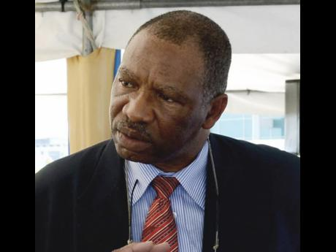

***Mr Jeffrey Spooner***

Source: Jamaica Gleaner

16. The CMO also salutes ***Mr Dennis Gonguez***, Chief Meteorologist/Director of the National Meteorological Service of Belize, on his retirement from the end of 2016. Mr Gonguez has more than 30 years experience in the fields of weather, climate and disaster management. Like most professional weathermen in the Caribbean, he started his career with courses at the CIMH. In 1987, he obtained the WMO Class II certificate in Weather Analysis and Forecasting, then a few years later, he was awarded a Bachelor's Degree in Meteorology from Millersville University of Pennsylvania. Mr Gonguez later obtained a Master’s Degree in Atmospheric Sciences and Meteorology from the South Dakota School of Mines and Technology, with a major in Cloud Physics and Radar Meteorology. The Organs of the Caribbean Meteorological Organization thank them both for their valuable contribution and wish them well in their new ventures. The CMO welcomes their respective replacements, *Mr Evan Thompson* in Jamaica and *Ms Catherine Cumberbatch* in Belize.

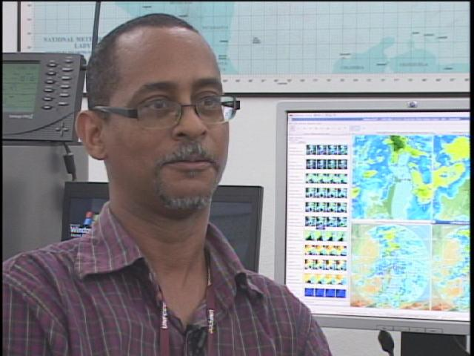

***Mr Dennis Gonguez***

Source: Channel 5 Belize

**Action Proposed to Council:**

17. **The Council is invited to**:

1. **Note** the activities and issues concerning the CMO Headquarters in 2016, particularly those dealing with the implementation of major WMO-related activities, and issues concerning the wider Caribbean Community;
2. **Discuss** the impact of the 2016 hurricane season on the region and, in particular, the impacts on CMO Member States.

_________

CMO Headquarters

October 2016

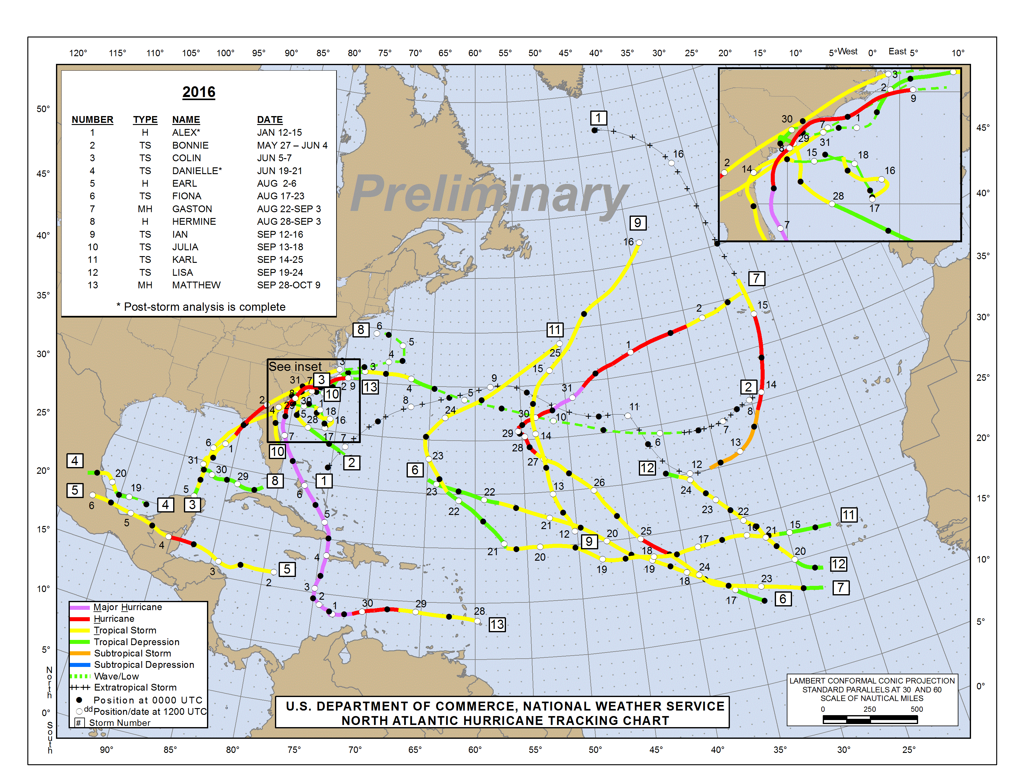

|  |  |  |
| --- | --- | --- |
| **2016 SUMMARY TABLE (TO OCTOBER 17)** | | |
| Name | Dates | Max Wind (mph) |
| H ALEX  TS BONNIE  TS COLIN  TS DANIELLE  H EARL  TS FIONA  **MH GASTON**  *TD EIGHT*  H HERMINE  TSIAN  TS JULIA  TS KARL  TS LISA  **MH MATTHEW**  **MH NICOLE** | 12-15 JAN  27MAY-4JUNE  5-7 JUNE  19-21JUNE  2-6 AUG  17-23 AUG  **22 AUG-3 SEP**  28 AUG-1 SEP  28 AUG-3 SEP  12-16 SEP  13-19 SEP  14-25 SEP  19-25 SEP  **28 SEP-9 OCT**  **4 17 OCT**- | 85  45  50  45  80  50  **120**  35  80  60  40  70  50  **160**  **130(E)** |

**Figure 1**: 2016 Tropical Storms and Hurricane tracks (preliminary) in the Atlantic-Caribbean basin–Mid-October (courtesy NOAA/NHC)

2016 CMO HQ Missions

##### (Not related to the CMC meetings)

January 9 **WMO/NOAA-NWSInternational Session** on the theme "*Emerging Data Challenges: Big Data, Social Media and Crowd Sourcing*"

*in conjunction with*

January 10-14 96th**American Meteorological Society** (**AMS**) Annual Meeting, New Orleans, Louisiana, USA.*[CD and STO]*

January 25-28***WMO Inter-Commission Coordination Group on WIGOS*** *(ICG-WIGOS), 5th Session, WMO Secretariat, Geneva [CD]*

February 2 **CARICOM***Virtual Cluster Meeting on the Community Strategic and Operational Plans, 1*st*meeting for 2016[CD]*

March 7 **CARICOM***Cluster Meeting,* CCS Guyana *[CD]*

March 8 ***CARICOM*** *-Seventh Meeting of the Secretary-General, Caribbean Communityand Heads of Community Institutions*, CCS Guyana *[CD]*

*in conjunction with*

March 9 Sixth Meeting of the *Consultative Committee on Technical Cooperation* (Member States, CARICOM Secretariat and Community Institutions)

*in conjunction with*

March 10-11 Fourth *High-Level Forum on Donor Coordination* (CARICOM Secretariat, Member States, Community Institutions & International Development Partners)

March 14-18 ***WMO*** *- EC Panel of Experts on Education and Training*, Florence, Italy *[Dr David Farrell, member]*

March 17-18 **TTMS***Workshop on the Use and Interpretation of Weather Information for Aviation and Search & Rescue*, Piarco Int'l Airport, Trinidad *[STO*]

April 14-15 **NOAA/USAF Caribbean Hurricane Awareness Tour** (CHAT), Tortola, BVI *[CD]*

April 17-22 **American Meteorological Society** (**AMS**) *32*nd *Conference on Hurricanes and Tropical Meteorology*, San Juan, Puerto Rico

*in conjunction with*

April 21-26 **WMO RA IV Hurricane Committee**, 38th session, San Juan, Puerto Rico*[CD, STO, J. Tibbetts & A. Ebanks, Cayman Isl., H. Whyte, Grenada]*

May 18-20 **WMO** *Regional Basic Observing Network (RBON) Workshop*, Geneva [to include chairs of the regional TT-WIGOS] *[STO]*

May 25-31 2016 Wet/Hurricane Season **Caribbean Regional Climate Outlook Forum** (**CARICOF**), Roseau, Dominica

* Workshop, May 25-28 – focus on *Health and Disaster Risk Reduction*
* Stakeholder Outlook Forum, May 30-31 – *[CD]*

June 13 or 14 **WMO** – *EC Panel on Capacity Devel*opment, first session, Geneva, Switzerland *[CD - Co-Chair]*

on the margins of

June 13-14 **WMO FINAC**-35, Geneva

*in conjunction with*

June 15-24 68th session of the **WMO Executive Council**, *[CD, STO, P/CIMH and J.Tibbetts]*

June 22 CARICOM - *Virtual Cluster Meeting on theRevision of the Community Implementation Plan 2015-19[STO]*

July 22 **CARICOM***Virtual Cluster Meeting on the Community Strategic and Operational Plans,* - 2nd Joint Virtual Pillar Meeting [*CARICOM Committee of Ambassadors (CCA) and members of the four (4) Pillars, i.e. the Technology, Social, Environmental and Economic Pillars*.] *[CD]*

September 5-8 **WMO** *Second Meeting of the Coordination Group on Satellite Data Requirements in Region III and IV* (RA-3-4-SDR-2), Willemstad, Curaçao *[STO and K-A Caesar, CIMH]*

October 21 **ACS** *24th Meeting of the Special Committee for Disaster Risk Reduction,* ACS Secretariat, Port-of-Spain *[CD]*

October 26 **CCS/CCJ***Meeting to Consider the Agreement Establishing the Caribbean Community Administrative Tribunal* (CCAT), the Sonesta, Sint Maarten *[FAO]*

- - - - - - - - - - - - - - - - - - - - - - - - - - - - - - - - - - - - - - - - - - - - - - - - - - - - - - - - - - - - -- - - - - - - - - - -

November 16 **NASA/NOAA** - *The launch of* ***GOES-R***, Kennedy Space Center, Florida, USA *[E. Thompson, Jamaica, K-A Caesar, CIMH]*

November 21 (week of.) **CDEM**A *CDM Programming Consultation*, Barbados [Postponed from Oct *[STO]*

November 21-22 **WMO Commission for Basic Systems***Technical Conference 2016* - "Emerging Trends in Information and its Use"

*in conjunction with*

November 23-29 **WMO Commission for Basic Systems – 16th Session** (CBS-16), Guangzhou, China *[CD]*

December 5-6 **Caribbean Regional Climate Outlook Forum** (3rd Dry Season **CARICOF**), Stakeholder Forum, St. George's, Grenada *[STO]*

December 13-15 ***WMO Preliminary Meeting on the SWFDP for RA IV***, Regional Forecast Facility of Martinique (RAIV SWFDP Experts)

- - - - - - - - - - - - - - - - - - - - - - - - - - - - - - - - - - - - - - - - - - - - - - - - - - - - - - - - - - - - -- - - - - - - - - - -